Business Requirement Document for Preparation & Review of advance schedules in SAP
SAP R3 Module | SAP FICO
Document Date | 01.06.2025
Prepared By | Laxmi Kurane
Business Owner | Mr. Dilip Lohani
SAP Functional | SAP FICO Team
System Development requirement | RTGS process need to automated and system generated file to be created for RTGS Payment.
Background | Currently we are processing the RTGS/ NEFT/IMPS payments manually.  Current process followed is as under:  - Statement received with password from email id as per below screenshot.  - This mail is received with a fix subject line as “StandcVA”  - It is received 3 times in a day at 3 PM, 5 PM and between 11:57 To 11:59 PM  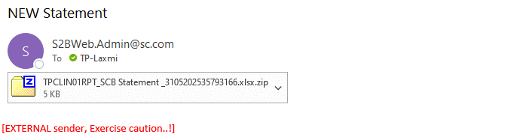  1. From The above file we will not consider UPI line items. These line items are to be EXCLUDED  2. Logic to identify UPI transactions is in column “Transaction UPI COLLECTIONS” column, the description mentioned is “UPI” (Only UPI)  3. Other than “UPI” mentioned in column “CR UPI/553214622199/ 3082900000864466” where UPI is followed by some no. is to be considered.  4. All other line items are to be considered.  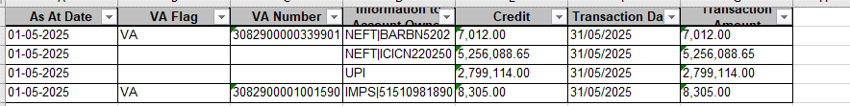  3 . Copy all the details from the statement file and paste them in one master file of RTGS by deleting the old/previous records. (Master file screenshot is given below)  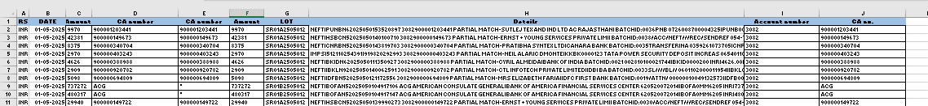  Now all the further work will be carried out in the master file.  - Need proper formatting in file and do the selection of ‘9’series CA Numbers and export those CA numbers in the T-code-ZCARP076  - Dates to be mentioned in the below T code are explained below:  Example: if we are working on file dtd. 12.06.25, then from and to date in 76 T code above will be from 1st June till 30th June  So, from start of the month till end of the month. (Can be explained during discussion call)  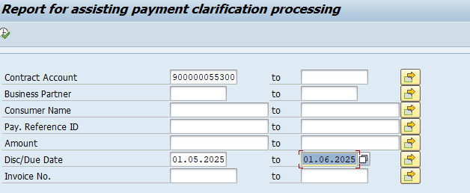  5. Once we export the data, we do VLOOK into export file need to map the details from day-to-day file with export file.  after VLOOKUP we get one data and again with the same, we have to do the VLOOK in day-to-day file as attached in 2 Row.  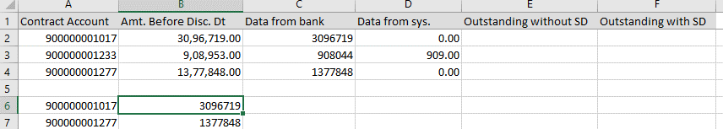  2.  3 After the VLOOKUP, we received some data matching with demand and receipt and balance data we have to check manually with matching the customer due and payment receive, in some cases have to mail to concern team for consumer details.  6. Once the file gets updated with details, we have to update those in converter file as below.  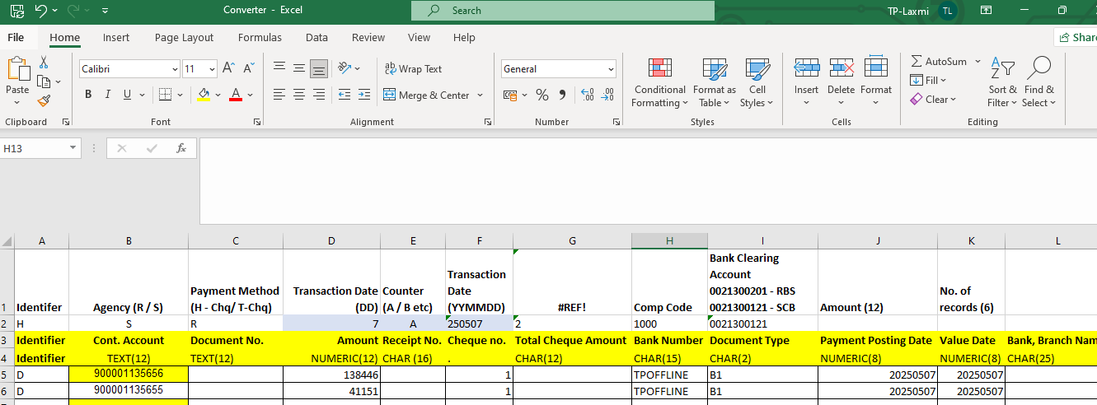  7 Once the convert run, we need to update the data in notepad and need to create lot file.  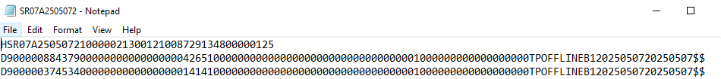  8 The lot created need to upload in t code-  ZCAEN005B  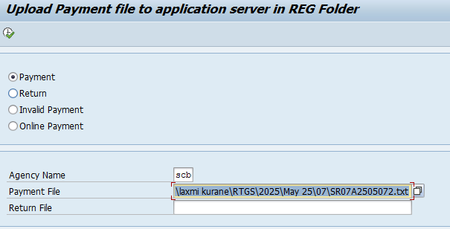  9 Need to processed in t-code FP25  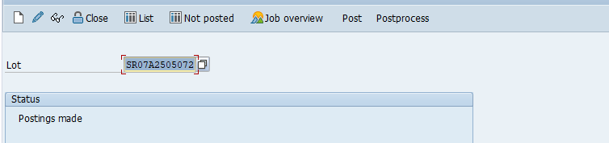
Process change required | - For RTGS process need to discussed for automation.  - We intend that maximum of this activity to be performed through BOT.
Benefits of implementing the new process | - Reduce manual work and time saving.  - Avg. 3 hours spent per day  - Improved Accuracy  - Enables high-volume transaction handling without additional resources.
Received on
Proposed Solution
Agreed Target date
Signed by Business | Mr. Poornima Acharya Mr. Dilip Lohani  (Vertical Head – Accounts Receivable) (Head – FOCE)
Signed by Functional
Actual Delivery date

